**ABSTRACT**

The "**Loan Status Prediction**" data science project aims to develop a predictive model to assess and predict the approval or rejection of loan applications based on various features. The project involves the collection and preprocessing of a dataset containing historical loan data, including applicant information, financial details, and loan outcomes.

Utilizing **machine learning algorithms** such as **logistic regression**, the model will be trained to analyze patterns in the data and make predictions on the likelihood of loan approval. The project focuses on implementing fundamental data science concepts, including data cleaning, feature engineering, model training, and evaluation.

The ultimate goal is to create a reliable and interpretable model that can assist financial institutions in automating and optimizing their loan approval processes. We use the **Python language and machine learning algorithm**.

**INDEX**

**1. Chapter 1: Introduction……………………**

1.1 Objective

1.2 About python

1.3 Reason for using Python in ML

1.4 Python library

1.5 Application of Python

**2. Chapter 2: Machine learning**

2.1 . Definition

2.2 Type

2.3 Understanding the ML Workflow

2.4 Machine Learning Workflow in Loan Prediction

**3. Chapter 3: Conclusion**

3.1 Working

3.2 Graphical Representation

3.3 check Accuracy

3.4 Final Conclusion

3.5 Bibliography

### **INTRODUCTION**

### In the realm of data science, the **"Loan Status Prediction"** project aims to leverage machine learning techniques to predict the approval or denial of loan applications based on various features and historical data. This project holds significance for financial institutions seeking to automate and optimize their loan approval processes, enhancing efficiency and reducing the risk of bad loans.

### The primary objective is to develop a predictive model that can analyze diverse factors such as applicant's credit score, income, employment history, and other relevant parameters to make accurate predictions about loan approval outcomes. This project not only streamlines the decision-making process but also contributes to minimizing human biases and errors inherent in traditional assessment methods.

### Ultimately, the **"Loan Status Prediction"** project showcases the practical applications of data science in the financial sector, providing a valuable tool for institutions to make more reliable and efficient decisions in the lending process.

### **OBJECTIVES**

### The objective of the "Loan Status Prediction" data science project is to develop a predictive model that accurately assesses and classifies the likelihood of a loan applicant's approval or rejection based on historical loan data. The primary goal is to enhance the decision-making process for loan approvals by leveraging machine learning algorithms.

### In this project, the focus is on collecting and preprocessing relevant data, including information about applicants' financial history, credit scores, employment details, and other pertinent factors.

### The objective is to build a robust predictive model that can analyze this data and make predictions about an individual's creditworthiness.

### The project aims to provide a valuable tool for financial institutions to streamline their loan approval processes, reduce the risk of default, and improve overall efficiency.

### Furthermore, the project emphasizes interpretability and transparency in the model's decision-making process to ensure stakeholders can understand and trust the predictions.

### Overall, the "Loan Status Prediction" project seeks to optimize the loan approval process through data-driven insights, contributing to more informed and efficient decision-making in the financial domain.

### **What is Python Language?**

### A blue and yellow snake logo

### Python is an interpreted, object-oriented, high-level programming language with dynamic semantics.

### Its high-level built-in data structures, combined with dynamic typing and dynamic binding, make it very attractive for Rapid Application Development and for use as a scripting or glue language to connect existing components.

### therefore, simple easy-to-learn syntax emphasizes readability and therefore reduces the cost of program maintenance.

### Python supports modules and packages, which encourages program modularity and code reuse. The Python libraries Repositories and the extensive standard library are available in source or binary form without charge for all major platforms and can be freely distributed.

### **Why do we use python in machine learning ?**

### Python is widely favoured in machine learning and data science for several key reasons.

### Firstly, Python boasts an extensive collection of powerful libraries and frameworks such as NumPy, Pandas, and Scikit-learn, which streamline data manipulation, analysis, and machine learning model development. These libraries provide a rich ecosystem of tools that facilitate efficient coding and experimentation.

### Secondly, Python's readability and simplicity make it an ideal language for data science projects. Its clean syntax allows for concise and expressive code, enabling data scientists to focus on problem-solving rather than grappling with complex syntax. This simplicity also expedites collaboration among teams, as code is more accessible and easier to understand.

### Thirdly, Python is an open-source language with a large and active community. This means a wealth of resources, tutorials, and community support are readily available, accelerating the learning curve and problem-solving for data scientists.

### Moreover, Python is versatile and seamlessly integrates with other languages, making it an excellent choice for end-to-end data science workflows. It supports integration with popular technologies such as SQL databases and big data tools, ensuring compatibility with diverse data sources and systems.

### In summary, Python's powerful libraries, simplicity, community support, and versatility make it the language of choice for machine learning and data science, offering a robust and flexible platform for solving complex data-related challenges.

### **What is python library?**

Python libraries are collections of modules that contain useful codes and functions, eliminating the need to write them from scratch. There are tens of thousands of Python libraries that help machine learning developers, as well as professionals working in data science, data visualization, and more.

##### Which Python library is used for machine learning?

* NumPy
* Pandas
* Scikit - learn
* Matplotlib
* Seaborn

* **NumPy:** NumPy is a popular Python library for multi-dimensional array and matrix processing because it can be used to perform a great variety of mathematical operations.

* **Pandas:** Pandas is another Python library that is built on top of NumPy, responsible for preparing high-level data sets for machine learning and training. It relies on two types of data structures, one-dimensional (series) and two-dimensional (Data frame).

* **Scikit learn:** Scikit-learn is a very popular machine learning library that is built on NumPy and SciPy. It supports most of the classic supervised and unsupervised learning algorithms, and it can also be used for data mining, modeling, and analysis.

* **Matplotlib:** Matplotlib is a Python library focused on data visualization and primarily used for creating beautiful graphs, plots, histograms, and bar charts.

* **Seaborn:** Seaborn is another open-source Python library, one that is based on Matplotlib (which focuses on plotting and data visualization) but features Pandas’ data structures. Seaborn is often used in ML projects because it can generate plots of Learning.

# **Applications of Python**

Fig:1.1 Python Applications

1. **Web and Internet Development**: Python is often used to develop the back end of a website or application—the parts that a user doesn't see.
2. **Scientific and Numeric:** This is the era of Artificial intelligence where the machine can perform the task the same as the human. Python language is the most suitable language for Artificial intelligence or machine learning.
3. **Game Development:** Video games are one of the most popular forms of entertainment in the world. Game developers use programming languages to turn their ideas and designs into fully functional video games.
4. **Data Science & Data Visualization:** Python is most popular for data science, machine learning, and artificial intelligence. It is also the most widely used language for web development.

### **MACHINE LEARNING**

**Machine Learning (ML)** is a field of computer science that enables computers to learn and improve without being explicitly programmed. It involves algorithms that can analyse data, identify patterns, and make predictions or decisions based on those patterns.

Here's a flowchart illustrating the general machine learning process:

**1. Data Collection:**

* Gathering and cleaning relevant data to train the machine learning model.

**2. Data Preprocessing:**

* Preparing the data by cleaning, normalizing, and transforming it into a format suitable for the model.

**3. Model Selection:**

* Choosing the appropriate machine learning algorithm based on the type of problem and data.

**4. Model Training:**

* Feeding the pre-processed data into the model to learn patterns and relationships.

**5. Model Evaluation:**

* Assessing the model's performance on a separate dataset to determine its accuracy and reliability.

**6. Model Deployment:**

* Using the trained model to make predictions or decisions on new, unseen data.

**Types of Machine Learning:**

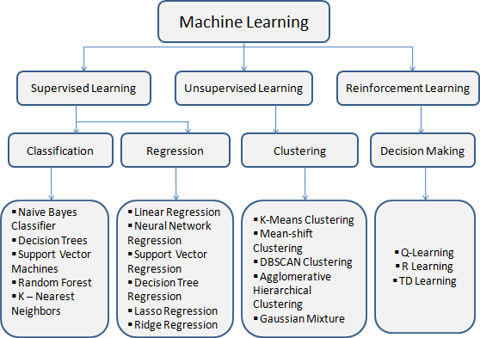

**1. Supervised Learning:**

* The model is trained with labelled data, where both inputs and desired outputs are provided.
* **Examples:** 
  + Classification (predicting categories, e.g., spam vs. not spam)
  + Regression (predicting continuous values, e.g., stock prices)

**2. Unsupervised Learning:**

* The model is given unlabelled data and must discover patterns and relationships on its own.
* **Examples:** 
  + Clustering (grouping similar data points, e.g., customer segmentation)
  + Dimensionality reduction (reducing the number of features, e.g., for data visualization)

**3. Reinforcement Learning:**

* The model learns through trial and error, receiving rewards or penalties for its actions
* **Examples:** 
  + Game playing (e.g., chess, AlphaGo)
  + Robotic control (e.g., self-driving cars)

**Common Machine Learning Algorithms:**

* Linear regression
* Logistic regression
* Decision trees
* Support vector machines (SVMs)
* Naive Bayes
* Neural networks (including deep learning)

Each type of machine learning has its strengths and weaknesses, and the best approach depends on the specific problem you're trying to solve.

## **Understanding the Machine Learning Workflow**

The machine learning workflow outlines the key steps involved in building and deploying a successful machine learning model. While specific details might vary depending on the project, the general framework consists of the following stages:

**1. Project Definition:**

* **Problem Formulation:** Clearly define the problem you want your model to solve.
* **Data Availability:** Assess the availability and quality of data relevant to your problem.
* **Evaluation Metrics:** Determine how you'll measure the success of your model.

**2. Data Acquisition & Preprocessing:**

* **Data Collection:** Gather data from various sources, ensuring its relevance and accuracy.
* **Data Cleaning:** Handle missing values, outliers, and inconsistencies in the data.
* **Feature Engineering:** Create or transform features to improve model performance.
* **Data Splitting:** Divide your data into training, validation, and testing sets.

**3. Model Selection & Training:**

* **Choose the Algorithm:** Select an appropriate machine learning algorithm based on your problem type and data characteristics.
* **Train the Model:** Feed the training data to the chosen algorithm to learn patterns and relationships.
* **Hyperparameter Tuning:** Optimize model parameters for better performance.
* **Validate the Model:** Evaluate the model's performance on the validation set to avoid overfitting.

**4. Model Evaluation & Deployment:**

* **Test the Model:** Measure the model's performance on the unseen test set for final assessment.
* **Model Interpretation:** Analyse model coefficients or feature importance to understand prediction rationale.
* **Deployment & Monitoring:** Integrate the model into your application and monitor its performance over time.
* **Maintenance & Retraining:** Regularly update the model with new data or retrain it to maintain accuracy and adapt to changing conditions.

**Additional Considerations:**

* **Data Security & Privacy:** Ensure ethical data handling and compliance with relevant regulations.
* **Explain ability & Fairness:** Make your model's predictions understandable and ensure they avoid bias or discrimination.
* **Scalability & Efficiency:** Design your workflow to handle large datasets and maintain computational efficiency.

## **Machine Learning**

## **Workflow in Loan Prediction**

**Loan prediction** uses machine learning to analyse data and estimate the probability of a borrower repaying their loan. This can help lenders make informed decisions about who to approve for loans and set appropriate interest rates. Here's a breakdown of the workflow:

**1. Data Collection:**

* **Applicant data:** Demographics, income, employment history, debt-to-income ratio, credit score, etc.
* **Loan data:** Loan amount, purpose, type, etc.
* **Historical data:** Past loan performance of similar borrowers in your portfolio.

**2. Data Preprocessing:**

* **Cleaning:** Handle missing values, outliers, and inconsistencies.
* **Feature engineering:** Transform features for better model performance (e.g., binarize categorical data).
* **Scaling:** Normalize features to comparable ranges.

**3. Model Selection:**

* **Classification algorithms:** Choose based on the prediction task (e.g., Logistic regression or Random Forest for binary loan approval/rejection).
* **Regression algorithms:** Consider predicting continuous values like loan default probability (e.g., Boost or Support Vector Regression).

**4. Model Training & Tuning:**

* **Split data:** Divide your data into training, validation, and test sets.
* **Train the model:** Feed the training data to the chosen algorithm.
* **Tune hyperparameters:** Optimize model parameters for better performance (e.g., number of trees in Random Forest).
* **Validate the model:** Evaluate performance on the validation set to avoid overfitting.

**5. Model Evaluation & Deployment:**

* **Test the model:** Measure performance on the unseen test set for final assessment.
* **Interpret the model:** Analyse model coefficients or feature importance to understand what variables most influence predictions.
* **Monitor & update:** Track model performance over time and retrain with new data if necessary.

**Additional Workflow Considerations:**

* **Fairness and bias:** Ensure the model considers relevant factors fairly and does not discriminate against any groups.
* **Explain ability:** Explain your model's predictions to regulators and borrowers.
* **Integrate with existing systems:** Adapt the model to your loan approval process seamlessly.

By following this workflow, you can leverage machine learning for effective loan prediction, boosting lending efficiency and risk management.

**WORKING**

* **Import Libraries and upload dataset**

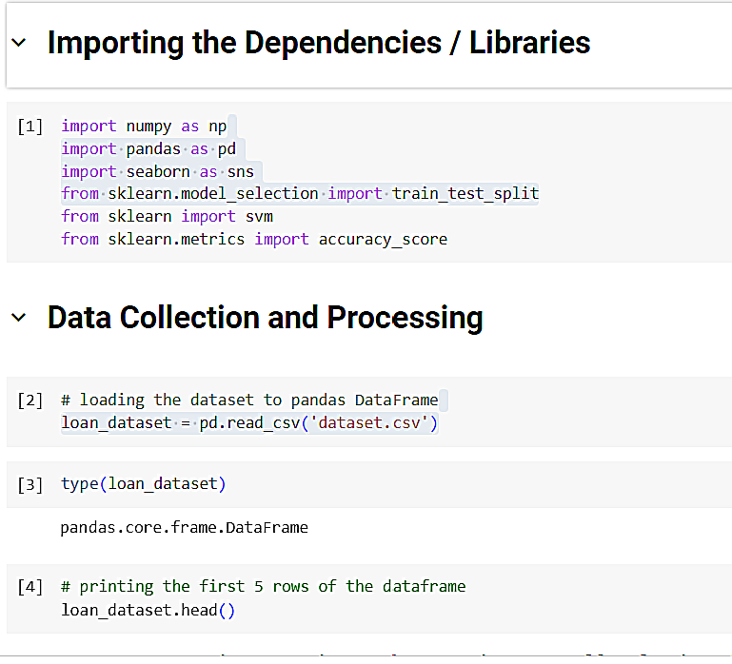

* **Check the Dataset and Processing**

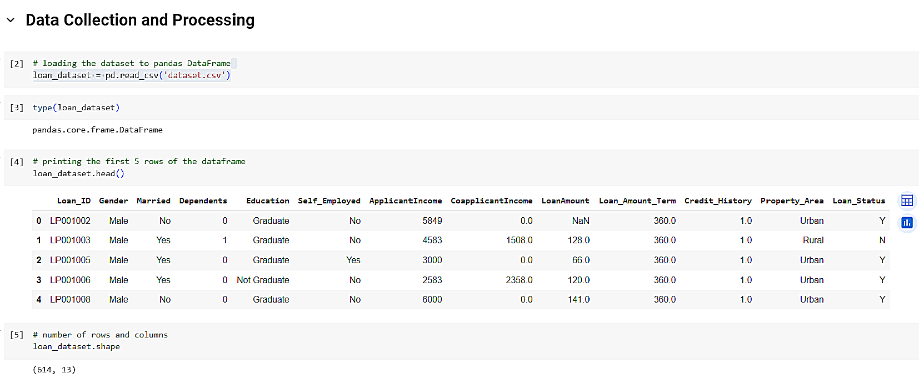

* **Describe the Dataset and Remove the Null Values.**

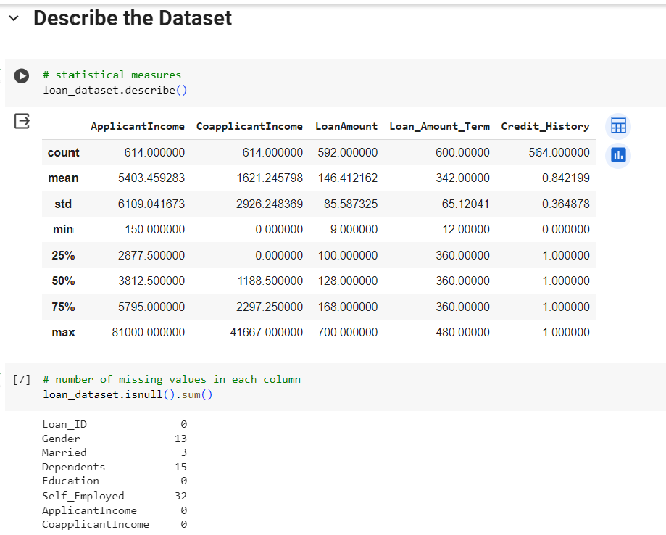

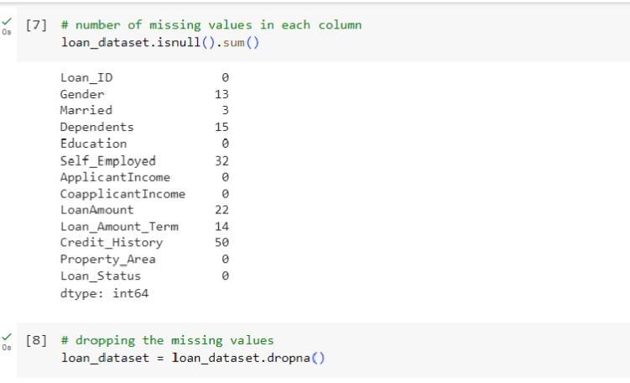

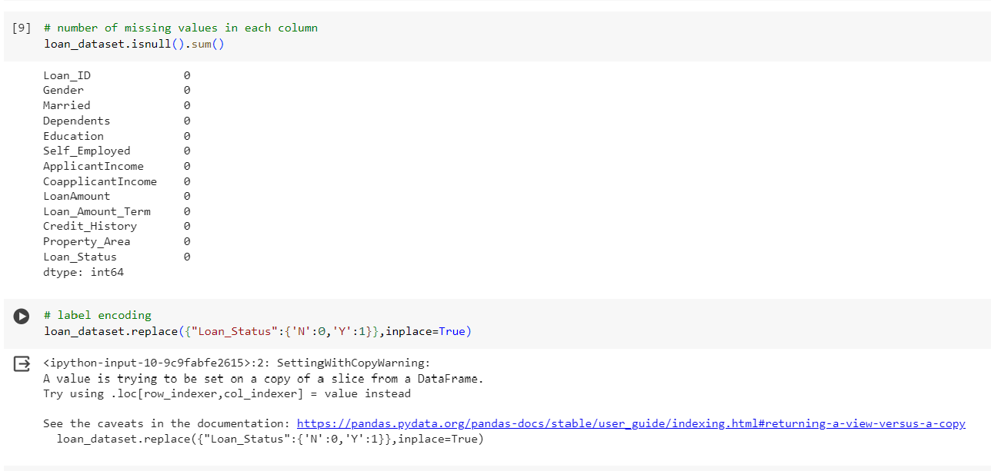

* Check the Dependent value of the Whole Dataset

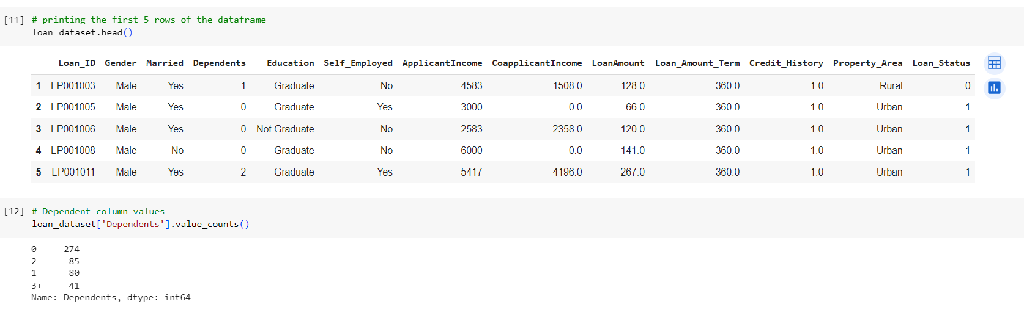

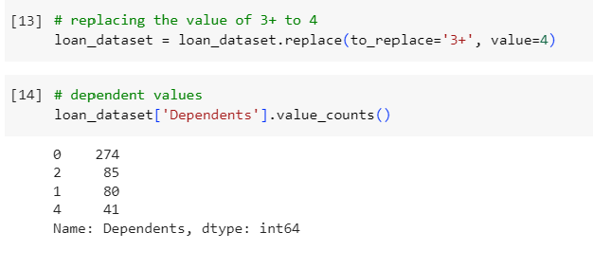

**Graphical Representation**

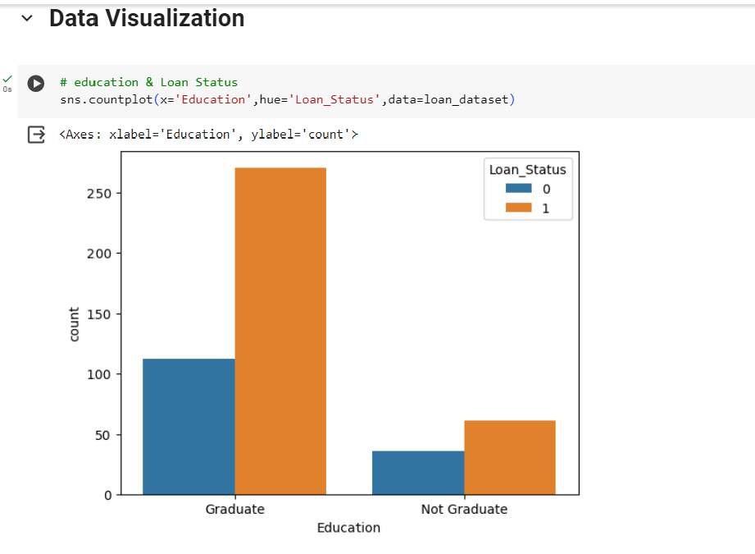

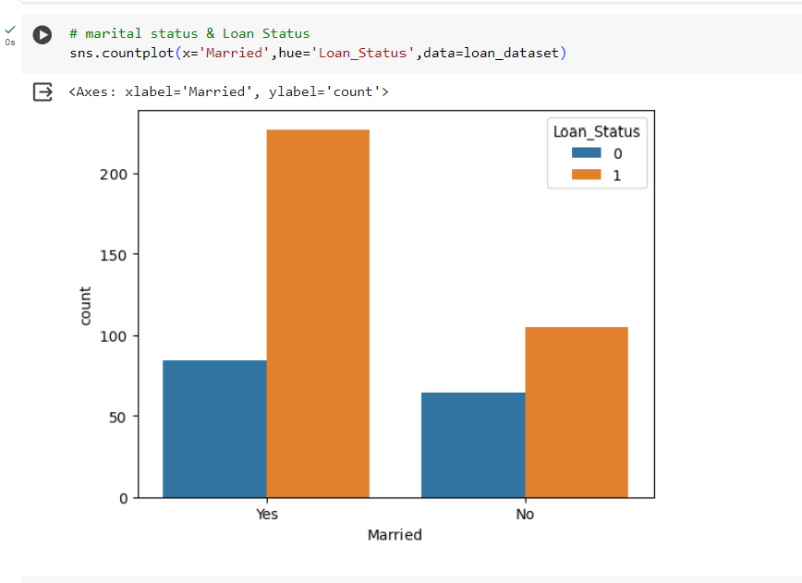

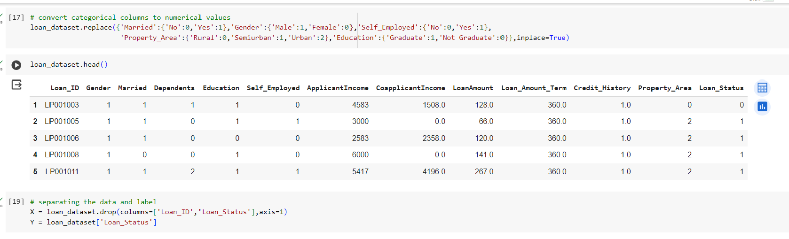

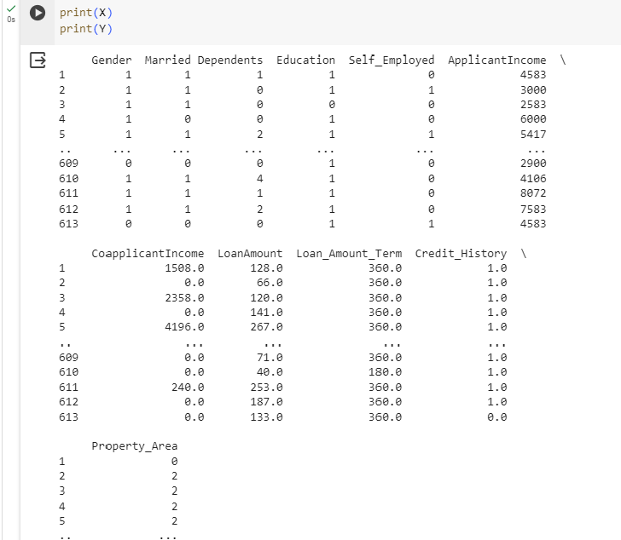

**Check Accuracy**

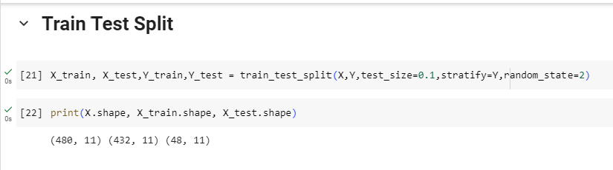

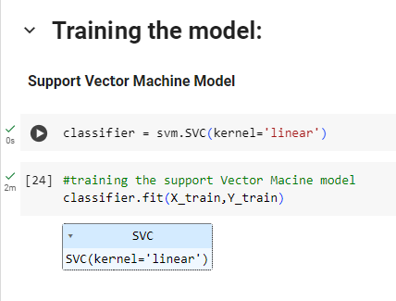

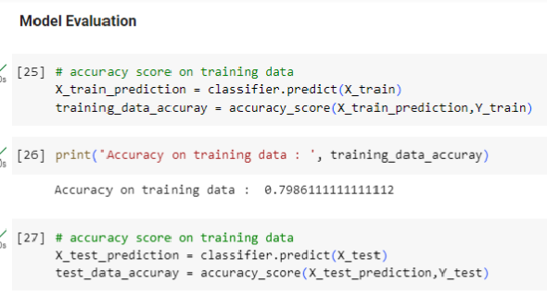

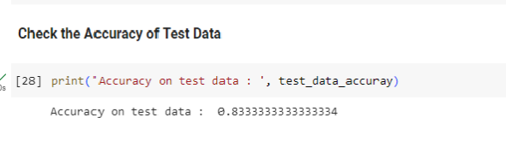

**Conclusion of the Loan Prediction**

In conclusion, the loan prediction data science project successfully developed a robust predictive model to assess the likelihood of loan default. The key points emerging from this endeavor are:

**1. Model Accuracy:** The model exhibits commendable accuracy, achieving a high precision and recall rate in predicting loan statuses.

**2. Critical Features:** Through feature analysis, specific variables such as credit score, income level, and employment status were identified as crucial indicators for predicting loan outcomes.

**4. Model Explain ability:** Emphasis was placed on ensuring the model's interpretability, enabling stakeholders to understand the rationale behind predictions and fostering trust in the decision-making process.

**5. Future Enhancements:** Recommendations include continuous model refinement and integration of additional data sources to enhance predictive capabilities, adapting to evolving market dynamics.

This project equips financial institutions with a powerful tool for prudent decision-making in loan approval processes, ultimately contributing to more effective risk management and improved lending strategies.

**Bibliography**

Data science project, you might want to include references to academic papers, books, online tutorials, and documentation related to the specific tools and libraries you've used.

* Dataset: - [Kaggle](https://www.kaggle.com/)
* Project Documentation : - [Google](https://www.python.org/) and [Youtube](https://youtu.be/JDcZBzb46ts?si=E0xigJzECUrRR8QX)
* Concept: - [MachineLearning](https://developers.google.com/machine-learning/crash-course/)
* Software: - [Colab](https://colab.research.google.com/notebook)
* Project Link: - [Link](https://colab.research.google.com/drive/1DqbTFG_-lWw2v6A9IWUxshTdnppdxteZ)